Context diagram

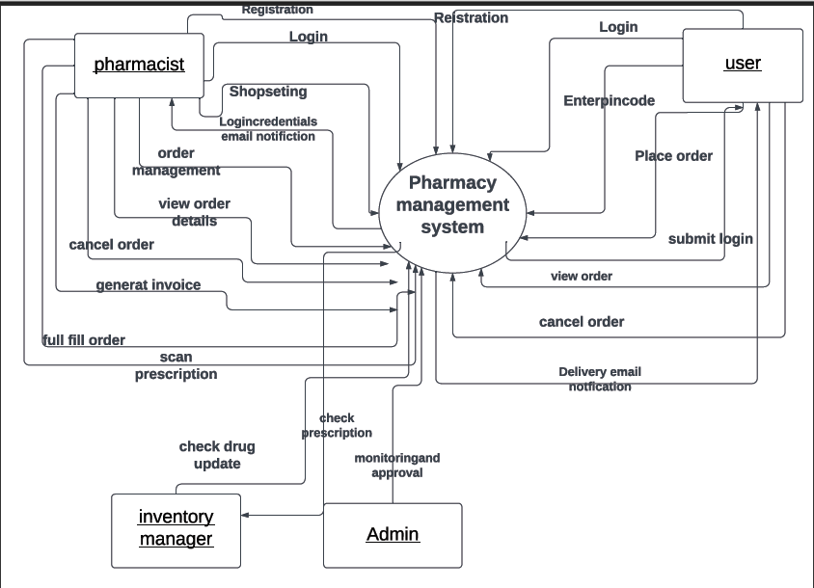

Personas

- patients

- users

-doctors